CREATE A DATABASEINCLOUDANTDB

|  |  |
| --- | --- |
| Date | 21-10-2022 |
| TeamID | PNT2022TMID41886 |
| ProjectName | Project-IOTbasedsafetygadgetforchildsafety monitoringand  notification |
| MaximumMarks | 4Marks |
| SubmittedBy | S.Preethika |

CreateADatabaseInCloudantDB

Aim:TocreateadatabaseinCloudantDBtostorelocationdata.

Stepsfollowed:

* LoggedintoIBMCloudaccount
* Navigated to`./resources`
* Clickedonthe“CreateResource+”button
* Searchedfor“Cloudant”
* Chosethe“LiteVersion”andclickedon“Create”

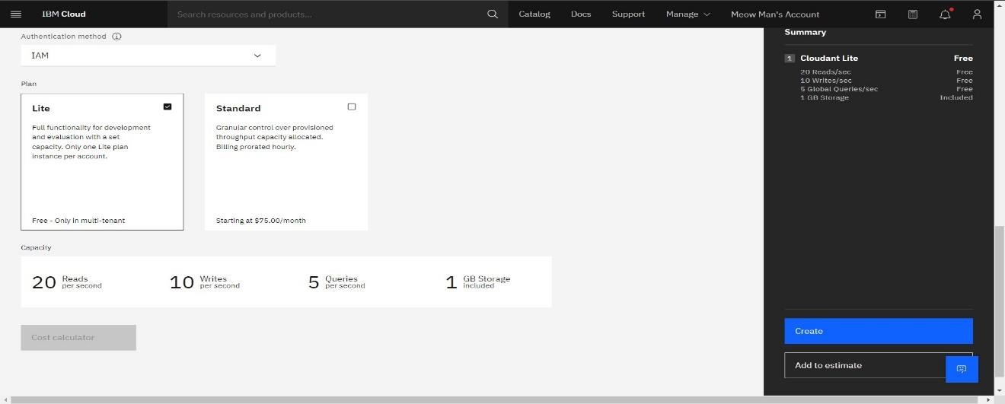

*Your text here*32*4*1

* TheCloudantdatabaseresourcewascreatedsuccessfully

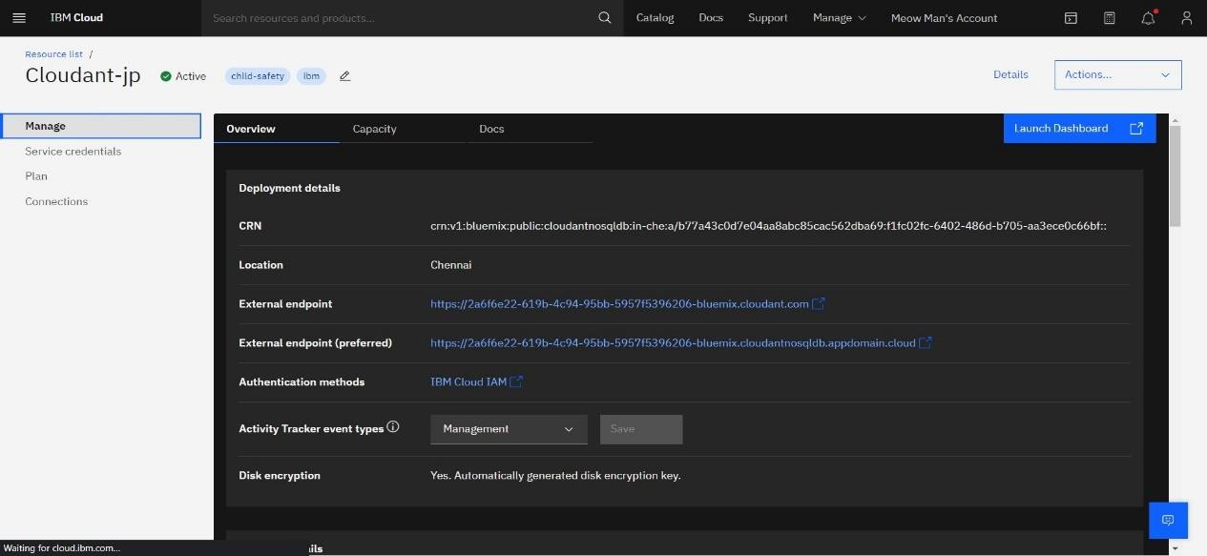

* ClickedonLaunchDashboard

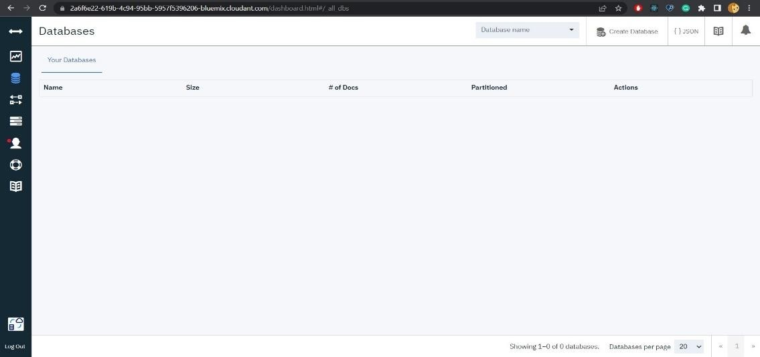

* Clickedon“CreateDatabase”.Entered“meowman”asthedatabasenameandthe“Non-partitioned”option

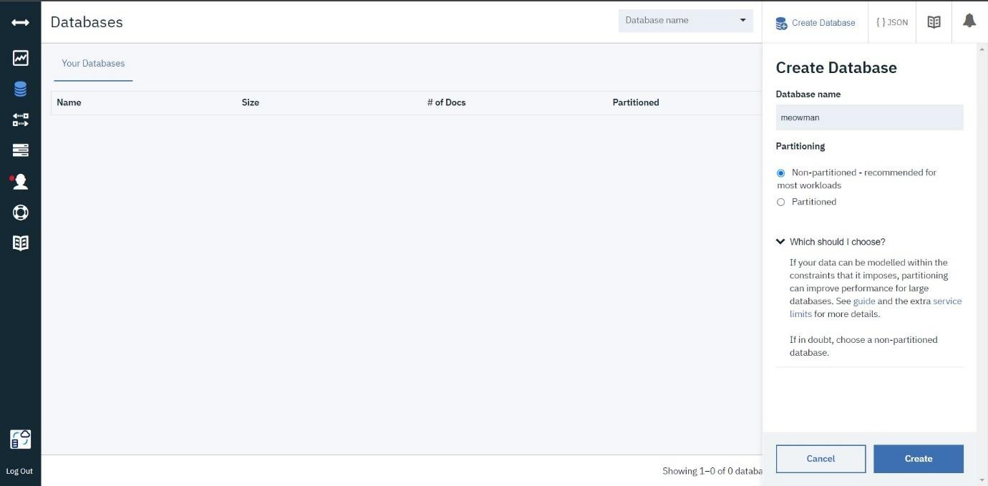

* Thedatabase“meowman”wascreatedsuccessfully

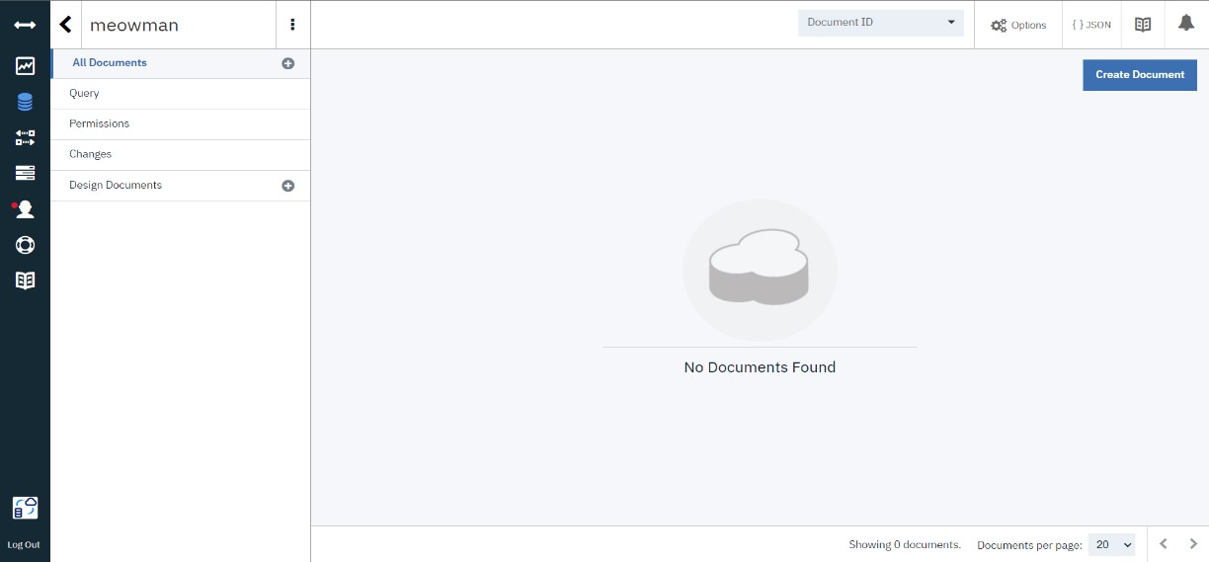

Result:

Adatabasetostorethelocationdatawas createdsuccessfullyonCloudantDB